Verb HAVE GOT Avere
 | AFFERMATIVA + | NEGATIVA - | INTERROGATIVA ?
 | I have got  (I’ve got)  ho | I have not got  (I haven’t got)  non ho | have I got ..?  ho …?
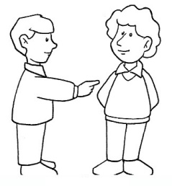 | you have got  (you ‘ve got)  hai | you have not got  (you haven’t got)  non hai | have you got..?  hai…?
 | he has got  (he’s got)  ha | he has not got  (he hasn’t got)  non ha | has he got …?  ha … ?
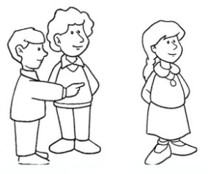 | she has got  (she’s got)  ha | she has not got  (she hasn’t got)  non ha | has she got…?  ha … ?
 | it has got  (it’s got)  ha | it has not got  (it hasn’t got)  non ha | has it got… ?  ha … ?
 | we have got  (we‘ve got)  abbiamo | we have not got  (we haven’t got)  non abbiamo | have we got...?  abbiamo …?
 | you have got  (you‘ve got)  avete | you have not got  (you haven’t got)  non avete | have you got..?  avete…?
.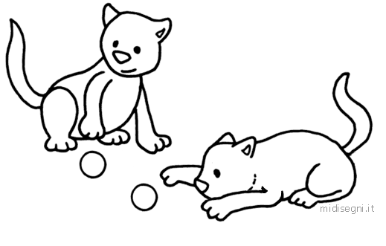 | they have got  (they‘ve got)  hanno | they have not got  (they haven’t)  non hanno | have they got?  hanno … ?

